**Html Page 1: Facts on Fireworks**

* Create the page as shown below. The file name must be ***facts.html***
* All the text and images are provided. You will find them in the *Guy Fawkes* folder.
* The text is in a text file called *Starter Text.* This contains the text for page 2 as well.
* The image file needed for this page is called *fireworks.gif*
* All image tags must include the attributes width, height and alt.
* Use a font other than the default for all the text.
* Add a background colour to the page. Make sure that the text can still be easily read.
* The text colour is to be black except for the table where you follow the pattern shown below.
* Check the *Html Test and Guide* file for more instructions
* “History of Guy Fawkes” (top right) is to be a hyperlink to the second html page  
  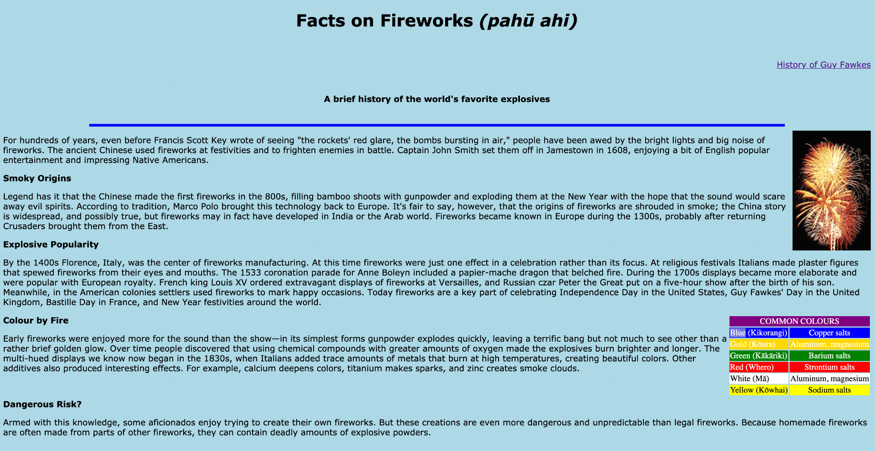

**Html Page 2: A Brief History of Guy Fawkes Day**

* Create the second page as shown below. The file name is to be *history.html*
* Use the text in the *Starter Text* file.
* The image file needed for this page is called *guys.gif*
* All image tags must include the attributes width, height and alt.
* Use a font other than the default for all the text.
* The background colour for the page is to be the same as for *facts.html*.
* *Back to fireworks page* is to be a hyperlink to *facts.html*.

